

CampusEats – A Student-Friendly Restaurant Website
Jamie Dalipi (0189707L), Christopher Francis (0458936A), Julian Cilia (0169007L),
B.Sc. (Hons) Software Development

Study-unit: Principles of Web Application Architecture
Code: CIS 1054
Lecturer: Prof. Chris Porter

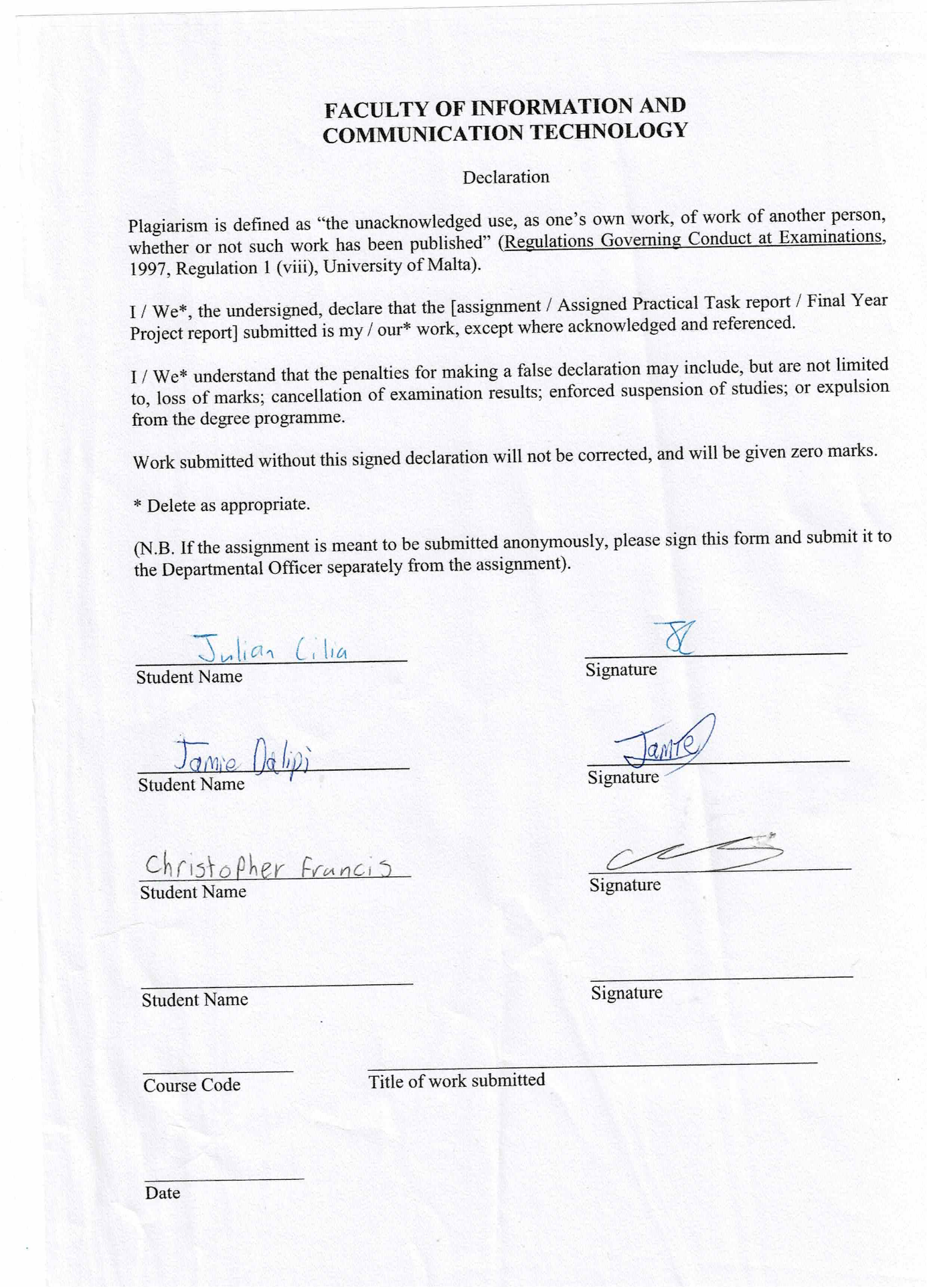

Index
- Requirements Coverage………………………………………………………………….1
1.2. Separation Of Concerns………………………………………………….2
1.3 Security……………………………………….…………………………………..4
1.4 Fallbacks………………………………………………………………………….6
- Libraries Used…………………………………………………………………………………7
- Features Applied In This Project………………………………………………………7
3.2 Cookies………………………………………………………………………….10

Requirements Coverage
A major aspect of this study unit was learning the proper best practices of web application architecture rather than learning the syntax. Therefore, best practices were taken into consideration when developing the website.

Functional Requirements
When learning how to build a website from the lectures and W3Schools, we had to implement all the given features provided in the assignment. With regards to the landing page, I had to look up images with Pexels and storing them in an Assets folder to which they’re rendered from. In addition, I also had to set up the Google Maps API and used ChatGPT to implement a short JavaScript snippet which showed an animation with the navigation bar whenever the user scrolled down.
While me and the others hardly had any problems implementing the other pages and I did the stylizing of them, the issue lied with implementing truncation in the About us and Contact pages. I had to code media queries for the navigation bar and columns to make sure that other resolutions get to see all the important contents without any issues.
I also had to update the database created by Christopher (which is a .json file), alongside the menu pages so that it renders all the data dynamically in one common page (aka. Category).

Separation of concerns
Separation of concerns was a major best practice that needed to be followed, this was achieved through separating the content, styling and behaviour of the website through HTML, CSS and PHP/JS files that were kept separate from each other, as seen in the pictures below
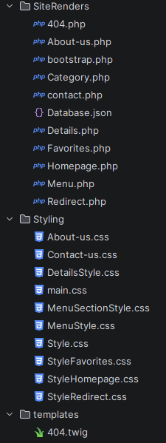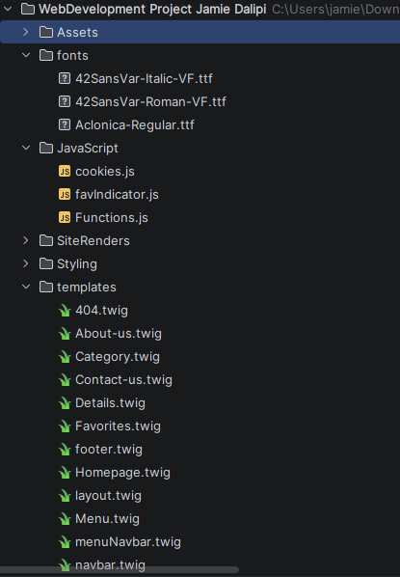

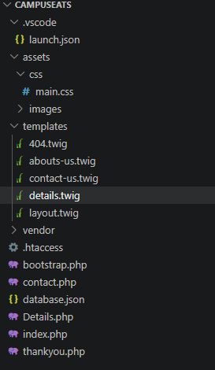
Our examples of separating concerns are based on the Shelter example from previous lectures:
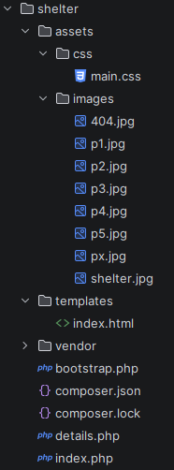

Security
Security is of the utmost importance in a web application, and it can never be assumed that malicious parties won’t take advantage of any security vulnerabilities to obtain data that they shouldn’t have. Security was ensured in two different ways; one method to maintain ensure security was the .htaccess file which prevents extension names form being used in the URL which protects resources from attackers such extensions include .ini, .json, .twig, .html.
.htaccess file:
php_flag display_startup_errors on
php_flag display_errors on

# Deny access to files with extensions .ini, .json, .twig, .html etc...
<FilesMatch "\.(twig|html|json|lock|ini)$">
Require all denied
</FilesMatch>

Options -Indexes
The second way that security was ensured was using the POST method rather than the GET method because GET puts the query string parameter data into the URL which can allow shoulder surfers to spy on users and their information
<form method="post" action=" <?php echo htmlspecialchars($_SERVER[PHP_SELF]);?>">
if ($_SERVER["REQUEST_METHOD"] == "POST") {
if (empty($_POST["name"])) {
if (empty($_POST["email"])) {
if(empty($_POST["message"])) {

Fallbacks
Multiple fallback fonts were used in case a user’s browser isn’t compatible with certain fonts
h1, p, h2{
font-family: "MyOtherCustomFont", "Roboto", "Open Sans", Arial, Helvetica, sans-serif;
}

Fallback text for images was also used in case an image fails to load for a user
<img src ="assets/images/pizza.jpeg" alt="Pizza">
<img src = "assets/images/caeser-salad.jpg" alt="Caesar Salad">
<img src = "assets/images/meal.jpg" alt="Meal">
<img src = "assets/images/Service-1.jpg" alt="Service 1">

There were also media queries implemented which made sure that certain unnecessary columns get removed once the resolution of the website reaches a certain size (e.g. 500px)
@media (max-width: 500px){
.logo{
display: none;
}
.container{
grid-template-areas: 'content';
grid-template-columns: 3fr;
}
}

Libraries used
The libraries used in this project were Apache via XAMPP and twig composer the templating engine

Features Applied In The Project
Throughout the entire project, we had to apply the knowledge we learnt from the lectures to implement an efficiently created website for CampusEats using XAMPP, Apache and the Twig Composer+Symphony features

Broad Implementations of Twig
The application of Twig with the usage of the libraries required to make twig files work made coding in HTML a lot more fluid and efficient since it can be used to prevent any form of redundant code in a couple of ways:
- Creating blocks of content to import them along the way: The block function is essential for creating one block of HTML code which is going to be applied in at least two or more HTML files, which is why writing block + include works.
TWIG FILE #1
{% block content %}
…
{% endblock %}
TWIG FILE #2
{% include ‘x.twig’ %}
This function was applied frequently to the Web Project, where the main navigation bar was used the most frequently:

navbar.twig
{% block content %}
<ul>
<li class="logo"><b>CampusEats</b></li>
<li>
<a href="../SiteRenders/Homepage.php"
class="{% if currentPage == 'home' %}active{% endif %}">
Home
</a>
</li>
<li>
<a href="../SiteRenders/About-us.php"
class="{% if currentPage == 'about' %}active{% endif %}">
About
</a>
</li>
<li>
<a href="../SiteRenders/contact.php"
class="{% if currentPage == 'contact' %}active{% endif %}">
Contact
</a>
</li>
</ul>
{% endblock %}
About-us.twig
{% block page_title %}About Us{% endblock %}
{% block content %}
<link rel="stylesheet" href="../Styling/Style.css">
<link rel="stylesheet" href="../Styling/About-us.css">
<body>
{% include 'navbar.twig' %}
...
- Dynamically loading pages and data from databases: This occurs when Twig has a feature to load data from a database and can create multiple different pages using one file based on twig conditionals. For example, in the WebProject, the Menu page has card-like links which take you to the Category page, but the Category page depending on what you click takes you to a section of the menu based off the hierarchal tree structure given in the project:
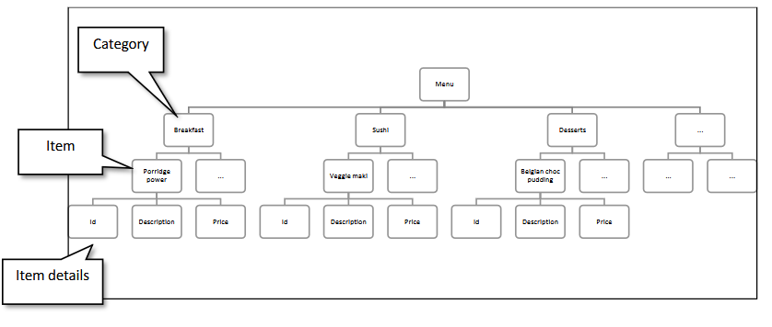
The code to implement this was searching for the content. The default category was breakfast whenever the code searches for a category.
It loads the items by ID and category in the form of a for loop for items:
Category.php:
{% for item in categoryItems %}
<a href="../SiteRenders/Details.php?id={{ item.id }}&category={{ item.Category }}">
<div class="item">
<img src="{{ item.image }}" width="200" height="200" alt="{{ item.name }}">
<h3>{{ item.name }}</h3>
<p>{{ item.desc }}</p>
<br>
<p>{{ item.price }}</p>
</div>
</a>
{% endfor %}
If you load the breakfast category, you’ll load items with category=breakfast.
The details page also makes use of dynamic loading, where you load the same page, but the item details are different depending on what item you click. The menu section fetches the id and category and loads the item:
Details.php:
<title>{{ item.name }}</title>
<link rel="stylesheet" href="../Styling/Style.css">
<link rel="stylesheet" href="../Styling/DetailsStyle.css">
<link rel="stylesheet" href="../Styling/main.css">
</head>
<body>
{% include 'navbar.twig' %}
<br><br><br><br>
<h1>{{ item.name }}</h1>
<img src="{{ item.image }}" alt="{{ item.name }}" width=10% height=20%>
<p>Price: {{ item.price }}</p>
<p>{{ item.desc }}</p>
<p>{{ item.ingredients }}</p>
<p>Category: {{ item.category }}</p>
...

Cookies
The cookies feature, implemented by Christopher, was used to track favorited items to which I updated to track how many items are favorited

Database
To make this project data oriented Christopher created a .json database with a simple database with a simple array structure that stores all menu items centrally, supporting our strict adherence to the separation of concerns. By separating our raw data from our template views, we ensure that adding or modifying items does not require altering our core structural code.

JSON Entry Structural Blueprint
Each new entry block appended to the database.json file must strictly follow this data blueprint to prevent template parsing or routing errors:
{
"img": "Assets/Images/imagename.fileExtension",
"desc": "description for owner of database",
"Name": "name of item",
"ID": "ID number ",
"longDesc": "Description for the website",
"Category": "Category EIement for where it is going",
"Price" : "Price element (if necessary) "
}
The unique ID serves as a strict primary key to uniquely identify each record, ensuring accurate data tracking when maintaining the user's favorited items. The Category field handles structural routing by sorting items into designated menu sections such as breakfast or drinks for dynamic template filtering. The img field establishes a direct asset linkage, meaning any file placed inside the Assets/Images/ subfolder automatically binds to that specific item data whenever it is invoked by the website.

